**Assignment -2**

Python Programming

|  |  |
| --- | --- |
| Assignment Date | 28-09-2022 |
| Student Name | Kiran Babu |
| Student Roll Number | 311019104038 |

1. Create a User table with Username, email, roll number, password
2. Perform UPDATE and DELETE queries
3. Connect python code to database
4. Create Flask app for a User registration and User login

**Solution:**

# App.py

from flask import Flask, render_template, request, redirect

import sqlite3 as sql import models as dbHandler

app = Flask(__name ) app.secret_key = 'fasdgfdgdfg'

@app.route('/') def home():

return render_template('home.html')

@app.route('/adduser') def new_user():

return render_template('add_user.html')

@app.route('/addrec',methods = ['POST', 'GET']) def addrec():

if request.method == 'POST': try:

email = request.form['email'] un = request.form['username']

rn = request.form['rollnumber'] pin = request.form['pin']

with sql.connect("User_database.db") as con:

cur = con.cursor()

cur.execute("INSERT INTO users (email,username,rollnumber,pin) VALUES (?,?,?,?)",(email,un,rn,pin) )

con.commit()

msg = "Record successfully added!" except:

con.rollback()

msg = "error in insert operation"

finally:

return render_template("list.html",msg = msg) con.close()

@app.route('/list') def list():

con = sql.connect("User_database.db") con.row_factory = sql.Row

cur = con.cursor() cur.execute("select * from users")

users = cur.fetchall()

return render_template("list.html", users = users)

if name == ' main ':

app.run(debug = True)

@app.route("/delete") def delete():

return render_template("delete.html")

@app.route('/deleterecord',methods = ["POST"]) def deleterecord():

un = request.form['username']

with sql.connect("User_database.db") as con: try:

cur = con.cursor()

cur.execute("DELETE FROM users WHERE username = ?",[un]) con.commit()

msg = "Record successfully deleted" except:

msg = "can't be deleted" finally:

return render_template("home1.html",msg = msg)

if name == ' main ':

app.run(debug = True)

@app.route('/deldb', methods = ["POST"]) def deldb():

con = sql.connect('User_database.db') cur = con.cursor() cur.execute('DELETE FROM users;') con.commit()

con.close()

msg = 'All the data has been deleted'

return render_template("home1.html",msg = msg)

@app.route("/log") def log():

return render_template("login.html")

@app.route('/login', methods =['GET', 'POST']) def login():

un = request.form['username'] if request.method=='POST':

users = dbHandler.retrieveUsers() msg = 'Logged in successfully!'

return render_template('welcome.html', users=un, msg=msg) else:

msg = 'You are not registered, would you like to be registered' return render_template('home1.html', msg=msg)

if name == ' main ': app.run(debug=False, host='0.0.0.0')

# Models.py

**import sqlite3 as sql**

def retrieveUsers():

con = sql.connect("User_database.db") cur = con.cursor()

cur.execute("SELECT username, pin FROM users") users = cur.fetchone()

con.close() return users

# sqlite_db_setup.py

**import sqlite3**

conn = sqlite3.connect('User_database.db') print("Opened database successfully")

conn.execute('CREATE TABLE users (email TEXT, username TEXT, rollnumber INTEGER, pin INTEGER)')

print("Table created successfully") conn.close()

# Home.html

**<h1>Welcome to User DB APP</h1><br><br>**

<a href="/">HOME</a><br><br>

<a href="/adduser">User Registration</a><br><br>

<a href="/list">List User</a><br><br>

<a href="/log">Log in</a><br><br>

<a href="/delete">Remove a User</a>

# Add_user.html

**<form action = "{{ url_for('addrec') }}" method = "POST">**

<h3>User Information</h3> E-mail<br>

<input type = "email" name = "email" /></br>

Username<br>

<input type = "text" name = "username" /></br>

Rollnumber<br>

<input type = "text" name = "rollnumber" /><br>

PIN<br>

<input type = "password" name = "pin" min="4" max="8" /><br><br>

<input type = "submit" value = "submit" /><p> </p>

<input type = "reset"/>

</form>

# list.html

**<!doctype html>**

<html>

<body>

<a href="/">HOME</a><br><br>

<a href="/adduser">Add New Student</a><br><br>

<a href="/list">List Student</a><br><br>

<br><hr>

{{ msg }}

<table border = 1>

<thead>

<td> Email </td>

<td> Username </td>

<td> Roll Number </td>

<td> Pin </td>

</thead>

{% for row in users %}

<tr>

<td>{{row["email"]}}</td>

<td>{{row["username"]}}</td>

<td> {{ row["rollnumber"]}}</td>

<td>{{row['pin']}}</td>

</tr>

{% endfor %}

</table>

</body>

</html>

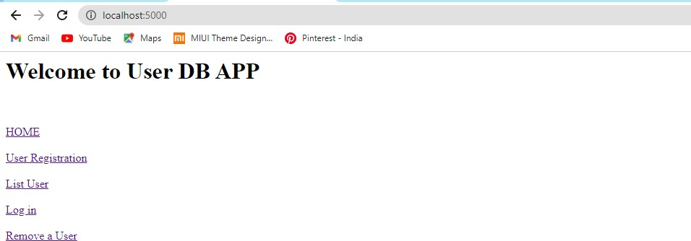

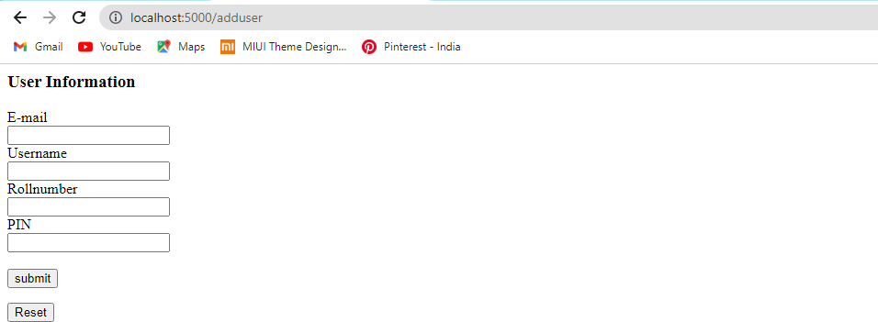

kiran@gmail.com

|  |  |  |  |
| --- | --- | --- | --- |
| Email | UserName | Roll Number | PIN |
| kiran@gmail.com | kiran | 311019054038 | 1234 |
| akash@gmail.com | akash | 311019104002 | 1111 |
| john@gmail.com | john | 31101910030 | 139 |

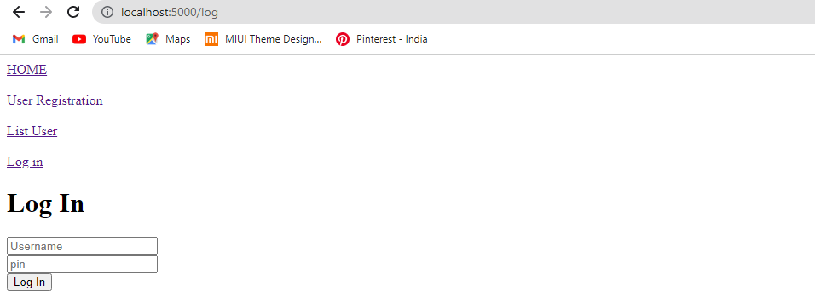

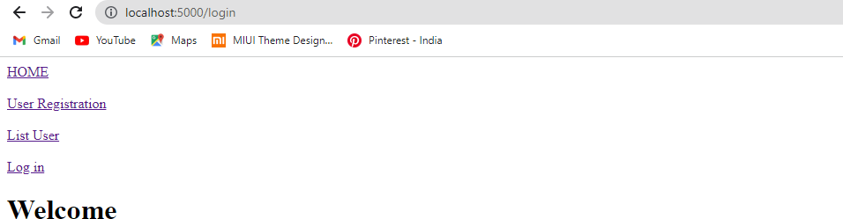

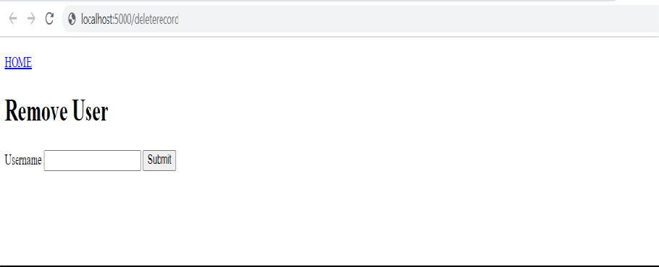

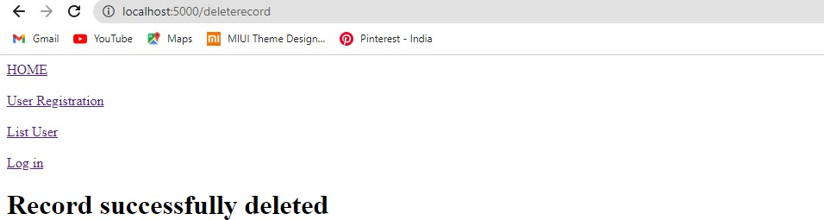

|  |  |  |  |
| --- | --- | --- | --- |
| Email | UserName | Roll Number | PIN |
| kiran@gmail.com | kiran | 311019104038 | 1234 |
| akash@gmail.com | akash | 311019104002 | 1111 |
| john@gmail.com | john | 31101910030 | 139 |